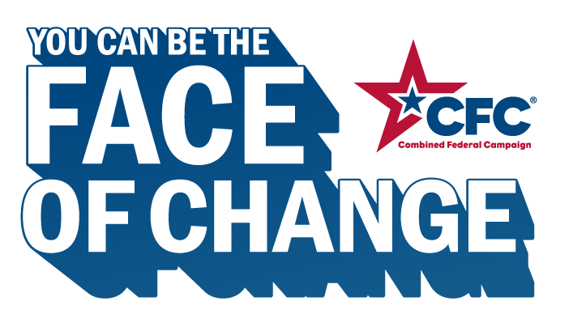



**MEET ENTER YOUR FIRST NAME.** Enter a word that describes you as a person . Enter a 2nd word that describes you as a person. Changemaker. Every year, Enter your first name gives through the CFC to support Enter a charitable cause you are passionate about and Enter a 2nd cause you are passionate about. The CFC makes it easy for all of us to change the world.